2006 STANDARD PROCEDURE MANUAL
of the
KOREAN WAR VETERANS
ASSOCIATION, INCORPORATED

[Date of adoption by the Board of Directors: October 10, 2006]

INDEX
STANDARD PROCEDURE MANUAL INDEX--------------------------------------- Pages 2-3
BYLAWS OUTLINE CROSS-REFERENCE INDEX-------------------------------- Pages 4-5
PURPOSE-------------------------------------------------------------------------------------- Page 6
PROCEDURE CHANGE METHOD----------------------------------------------------- Page 6
INTENT AND INTERPRETATION----------------------------------------------------- Page 6
RATIONALE---------------------------------------------------------------------------------- Page 6
ELECTED OFFICERS AND INSTALLATION CEREMONY-------------------- Page 7
OFFICERS’ AND COMMITTEES’ DUTIES AND RESPONSIBILITIES------ Pages 8-22
Elected Officers------------------------------------------------------------------------- Pages 8-10
President---------------------------------------------------------------------------- Page 8
First Vice President--------------------------------------------------------------- Page 9
Second Vice President----------------------------------------------------------- Page 9
Directors---------------------------------------------------------------------------- Pages 9-10
Appointed Officers--------------------------------------------------------------------- Pages 10-15
Secretary---------------------------------------------------------------------------- Pages 10-11
Treasurer--------------------------------------------------------------------------- Pages 11-12
Judge Advocate-------------------------------------------------------------------- Page 12
Chaplain---------------------------------------------------------------------------- Pages 12-13
Historian---------------------------------------------------------------------------- Page 13
National VAVS Director-------------------------------------------------------- Page 13
The Graybeards Editor----------------------------------------------------------- Page 14
Website/Database Technician-------------------------------------------------- Pages 14-15
Membership Administrative Assistant--------------------------------------- Page 15
Standing Committees------------------------------------------------------------------ Pages 15-20
Nominations/Election Committee--------------------------------------------- Pages 15-16
Finance Committee--------------------------------------------------------------- Page 16
Bylaws Committee---------------------------------------------------------------- Pages 16-17
Standard Procedure Manual Task Force ----------------------------- Pages 17-18
Membership Committee--------------------------------------------------------- Page 18
Resolutions Committee---------------------------------------------------------- Page 19
Reunion Committee-------------------------------------------------------------- Pages 19-20
Tell America Committee-------------------------------------------------------- Page 20
Special Committees--------------------------------------------------------------------- Pages 20-22
Ethics and Grievance Committee---------------------------------------------- Pages 20-22
ADDENDA------------------------------------------------------------------------------------- Pages 23-52
A-1 Membership Administrative Assistant---------------------------------------- Pages 23-24
D-1 Definitions-------------------------------------------------------------------------- Page 25
D-2 Board of Directors Agenda Item Form--------------------------------------- Page 26
E-1 Call for Election------------------------------------------------------------------- Page 27
E-2 Nominations/Election Committee, CPA Selection
and Ballot Preparation---------------------------------------------------------- Page 28
E-3 Ballot Counting Procedure------------------------------------------------------ Page 29
E-4 Election Ballot Tally Sheet Overall Votes------------------------------------ Page 30
E-5 Election Ballot Tally Sheet Summary----------------------------------------- Page 31
F-1 Procedure For Check Writing and Control---------------------------------- Page 32
F-2 Expenses Reimbursement Request Form------------------------------------- Page 33
F-3 Board of Directors Travel Reimbursement---------------------------------- Page 34
F-4 KWVA Travel Expense Report------------------------------------------------- Page 35
H-1 Annual Association Membership Meeting Hotel/Motel Check List---- Page 36
H-2 Annual Association Membership Meeting Hospitality Room Review-- Page 37
H-3 Hospitality Room Table of Usage---------------------------------------------- Pages 38-40
M-1 Official KWVA Membership Application Form--------------------------- Page 41
M-2 Certification of Eligibility For KWVA Membership---------------------- Page 42
M-3 Criteria for Membership in the KWVA------------------------------------- Page 43
N-1 Chapter/Department Formation Procedure -------------------------------- Page 44
N-2 Petition to Form a Chapter------------------------------------------------------ Pages 45-46
N-3 Petition to Form a Department------------------------------------------------- Page 47
N-4 Chapter/Department Charter Procedure------------------------------------ Page 48
N-5 Membership Committee Functions and Activities------------------------- Page 49
R-1 Resolutions/Bylaws Changes---------------------------------------------------- Page 50
R-2 Sample Resolutions/Bylaws Change Request-------------------------------- Page 51
R-3 Sample Letters Re: Resolutions/Bylaws Change Request----------------- Page 52

KWVA BYLAWS TABLE OF CONTENTS WITH CROSS-REFERENCE
TO THE STANDARD PROCEDURE MANUAL

CHARTER [Bylaws Pg #]

ARTICLE I Page 1

PREAMBLE

ARTICLE II Page 2

OFFICE

END OF CHARTER

ARTICLE I Pages 2-4

MEMBERSHIP

Section 1. Qualifications of Members [A-1, M-1 thru M-3] Pages 2-3
A. Regular Members Pages 2-3
B. Associate Members Page 3
C. Honorary Members Page 3
D. Ineligible Page 3

Section 2. Membership Procedures [A-1, M-1 thru M-3] Pages 2-3
A. Application Page 3
B. Termination of Membership Page 3
C. Resignation Page 3
D. Reinstatement Page 3
E. Transfer of Membership Page 3

Section 3. Dues [A-1, M-1] Page 4
A. Amount of Dues Page 4
B. Payment of Dues Page 4

ARTICLE II Pages 4-6
ELECTION OF OFFICERS [E-1, E-2]

Section 1. Officers Page 4

Section 2. Board of Directors Pages 4-5
A. Voting Page 4
B. Open Meeting Page 4
C. Special Meeting Page 4
D. Business Without a Meeting Page 5

Section 3. National Elections Pages 5-6
A. Regular Member Voting Page 5
B. Call for Election [E-1] Page 5
C. Offices to be Filled [E-1] Page 5
1. Requirements (a. through e.) Pages 5-6
D. Certification of Candidates [E-1] Page 6
E. Publication of Ballots in GRAYBEARDS [E-2] Page 6
F. Ballot Voting and Counting of Ballots [E-2:thru E-5] Page 6
Section 4. Term of Office Page 6
A. Elected Officers [E-1] Page 6
Section 5. Removal [D-2, paragraph D] Page 6
A. Expelling and Suspending Page 6
B. Removal from Office for Non-attendance Page 6
Section 6. Vacancies [E-1] Page 6

ARTICLE III Pages 6-8
OFFICERS POWERS AND DUTIES

Section 1. General Pages 6-8
A. President Page 7
B. Vice President Page 7
C. Secretary Page 7
D. Treasurer [F-1 thru F-4] Page 7
E. Appointed Positions Page 8
F. Board of Directors Page 8
G. Committees Page 8
Section 2. Indemnification Page 8

ARTICLE IV Page 9

ANNUAL ASSOCIATION MEMBERSHIP AND SPECIAL MEETINGS

Section 1. Association Membership Meeting Page 9
Section 2. Quorum and Voting Page 9
Section 3. Site Selection Page 9
Section 4. Majority & Proxy Voting Page 9
Section 5. Special Meeting Requirement Page 9

ARTICLE V Pages 9-12

DEPARTMENTS AND CHAPTERS

I. Departments [N-1, N-3, N-4] Pages 9-10
II. Chapters[N-1, N-2, N-4, N-5] Pages 11-12

ARTICLE VI Page 12

PARLIAMENTARY AUTHORITY

ARTICLE VII Page 12
ASSOCIATION OFFICIAL AND FISCAL YEAR

ARTICLE VIII Page 12

AMENDMENTS AND RESOLUTIONS

Section 1. Proposed Charter Amendments Page 12
Section 2. Bylaws Amendments [R-1 thru R-3] Page 12
Section 3. Resolutions [R-1 thru R-3] Page 12

1. PURPOSE:
A. The procedures outlined in this manual have been derived from experience with previous methods used by Officials in the performance of their duties as staff members of the Korean War Veterans Association. These procedures have been developed to assist new Officials, as well as the incumbents, to more efficiently perform their duties when adhering to the Bylaws.

B. They are designed to communicate to Officers, Directors, Standing Committee Chairpersons, Special Committee Chairpersons and members of the Korean War Veterans Association, Inc., proper and ethical procedures to use in conducting the Association’s business.

C. They are to provide clarification and fill in the detail of areas prescribed in the Bylaws that require action and the use of forms that are not covered specifically in the Bylaws.

2. PROCEDURE CHANGE METHOD:
A. These procedures may be modified by presenting recommended written additions/deletions or changes through appropriate channels to the Board of Directors for approval.

3. INTENT AND INTERPRETATION:

A. These procedures do not change the original intent of the Bylaws and may not be used to circumvent the Bylaws.

B. When in doubt as to the proper course of action to take, the Judge Advocate of the Association should be consulted.

4. RATIONALE:
A. There is an additional index of these procedures which is superimposed on the Bylaws Index to make for ease of cross-referencing easier [See pages 4 & 5 above.]

B. When more detailed instructions are deemed necessary to clarify or to give direction to a particular Bylaw, references are made to Addenda noted on Addenda Pages of this Manual.

ELECTED OFFICERS:

1. All vacant positions for Elected Officers and Directors shall be filled using first the individual who ran for a particular Office or Director position and received the highest number of votes. The President shall confirm that this individual will accept the office before the selection and approval by the Board of Directors.

2. Should there be no one running for a position, to be used as a recommended Officer or Director, the Board of Directors may recommend an individual to serve on the Board of Directors for approval, or may hold open the office until the next election by the membership, to complete the term.

3. Officers and/or Directors shall be installed, at the first opportunity available, after the election results are announced. The elected Officers and/or Directors will take office on June 25th .Any Board of Directors meeting scheduled thereafter will be conducted with the new Officers and/or Directors. Upon approval by the Board of Directors, the Secretary and Treasurer shall also be installed.

4. The Oath may be administered by using a document to be signed by the member assuming office as a part of the agenda when “Business Without a Meeting” is called.

INSTALLATION CEREMONY AND OATH OF OFFICE:

Installing officer requests the officers to be installed to come to the front, line up, facing the audience and says [words to the effect of]
“It is my honor to install the officers of the Korean War Veterans Association for the Administration Year 20**-20** They are:
President_________________________
1st Vice President__________________
2nd Vice President_________________
Secretary_________________________
Treasurer________________________
Others ___________________________

Please raise your right hand and repeat after me

[ "I, state your name ] , [ do solemnly swear to uphold the constitution of the United States of America, ]
[ the Bylaws and Procedures in the Standard Procedure Manual of the National Korean War Veterans Association, ] [ and I further promise that I will administer ] [ the duties of the office that I am about to assume to the best of my ability. ] [ Upon completion of my term of office, I further promise ] [ that I will turn over all records, equipment and monies ] [ that I have in my possession to my successor ] [ So help me God! ]
You may now lower your hands.
Ladies and gentlemen, with the power invested in me by the Korean War Veterans Association, I hereby declare the officers of the Korean War Veterans Association to be installed."

Shake hands with the officers installed, congratulating them, starting with the President and working down the line.

Note: Punctuation symbols in the oath above with brackets ] [ indicate phrasing breaks during the delivery of the oath by the installing officer (these may be modified to the installing officer’s individual liking).

OFFICERS’ AND COMMITTEES’ DUTIES AND RESPONSIBILITIES

A. ELECTED OFFICERS

1. PRESIDENT:

a. RESPONSIBILITIES

As the chief executive officer of the Association, provide the leadership essential to the day-to-day operations of the Association and in developing its future plans.

Insure compliance with the Bylaws and Standard Procedure Manual.

Protect the rights and interests of all members of the Association.

Initiate such actions as may be necessary to insure the financial viability of the Association.

b. DUTIES

The President shall notify the Board of Directors of all meetings including the date, time and place. This notification will be made by mail, with additional distribution by email and/or KWVA website. A proposed meeting agenda shall accompany the letter with instructions for each Board Member to respond if they will/will not attend and state if they have any business to conduct that should be placed on the agenda. A response time should also be given.

The President will preside at all meetings of the general membership and Board of Directors, following Robert’s Rules of Order, when the Bylaws or Articles of Incorporation do not have preference.

Meeting agenda and purpose of meeting shall be the responsibility of the President. Those Board of Directors members who have motions to present shall send a request (see Addendum D-2 for a request form) for every action item they want to place on the agenda, to the Secretary for inclusion on the agenda. A combined packet of all motions is to be sent to the Board of Directors by the Secretary to arrive at least a week before the meeting for study.

Should a crisis arise or a vote on an important item be required before the next scheduled meeting of the Board of Directors, a special meeting may be called or the crisis or question may be submitted to the Board of Directors, for approval, by a certified mail ballot, per the Bylaws, with a deadline for submittal and also a time period and person to contact for phone call questions that may arise from the Board of Directors.

Should mail be used for an approval, notification of the results shall be conveyed to the Board of Directors and then the vote affirmed at the next Board of Directors Meeting.

Serve as ex-officio member of all committees, except the Nominating Committee.

Appoint, with the advice of the Vice Presidents and approval of the Board of Directors, both Standing and Special Committee Chairpersons. Before submittal to the Board of Directors, be sure those who are suggested for appointments will accept the position.

After consultation with the two Vice Presidents, the President should divide the responsibility to coordinate and oversee the functions of the Standing and Special Committees among them.

2. FIRST VICE PRESIDENT:

a. RESPONSIBILITIES

Assume and perform the responsibilities and duties of President when absent. “Absent” is defined as the President being incapacitated to the point of being unable, physically or mentally, to perform his/her duties or not being physically present at a legally called meeting.

Serve as liaison between the committees assigned by the President and Board of Directors.

Coordinate the activities of all assigned committees.

b. DUTIES

Be prepared to assume the duties of President of the Association upon death, resignation, or termination of the President.

Assist the President in carrying out the responsibilities and duties of that office.

Volunteer to coordinate and be responsible for any Standing or Special Committee which he might have interest or in which he has qualifications, to effectively coordinate and oversee.

Perform such other duties as the President or Board of Directors may assign.

3. SECOND VICE PRESIDENT:

a. RESPONSIBILITIES

Assume and perform the responsibilities of the First Vice President when absent. “Absent” is defined as the First Vice President being incapacitated to the point of being unable, physically or mentally, to perform his/her duties or not being physically present at a legally called meeting.

Serve as liaison between the committees assigned by the President and the Board of Directors.

Coordinate the activities of all assigned committees.

b. DUTIES

Be prepared to assume the duties of the First Vice President of the Association.

Volunteer to coordinate and be responsible for any Standing or Special Committee which he might have an interest or in which he has qualifications to effectively coordinate and oversee.

Perform such other duties as the President or Board of Directors may assign.

4. DIRECTORS:

a. RESPONSIBILITIES

The Director, along with the other officers of the Board of Directors, shall be responsible for establishing the policy within which the association shall function. The Directors, collectively, shall control the Association’s property, be responsible for its finances and direct its affairs.

b. DUTIES

Attend all meetings on the dates called by the President. If unable to attend, notify the Secretary, stating why attendance is not possible. The Board of Directors will vote if the Director should be excused, according to the “defined reasons” decided upon by the Board of Directors, included in this Standard Procedure Manual as Addendum D-1.

Obtain a copy of the Association Bylaws and Standard Procedure Manual from the Association Secretary before the first scheduled Board of Directors meeting.

Review the various Standing and other Committees of the Association. If there is a personal preference for service, so advise the President.

Require an audit of the Association’s financial records.

Adopt an annual budget each year for the Association.

Review and consider all committee recommendations prior to voting upon these issues. It is recommended that Bylaws, Resolutions and motions for changes be obtained a week before the meeting for study where approval is required.

Motions to be presented to the Board of Directors shall be presented to the Secretary, using the Form shown in Addendum D-2, Board of Directors Agenda Items, in time for mail out in a packet to the Board of Directors.

The Board of Directors shall receive all Judge Advocate’s opinions given to Chapters, Departments, Directors, Committees and at-large members (except those given to the E & G Committee) and consider them as presented for action.

B. APPOINTED OFFICERS:

1. SECRETARY:

a. RESPONSIBILITIES

Keep an accurate record of proceedings of the Board of Directors and General Membership Meetings.

Maintain records of all approved minutes and changes of Board of Directors and General Membership Meetings.

Maintain a master file of the Association Articles of Incorporation, Bylaws, Standard Procedure Manual and Budgets.

Maintain file copies of Charters, Bylaws, Standard Procedure Manual, Reports of Elections and other correspondence concerning Departments and Chapters.

Submit the Call for Election in the November/December “The Graybeards” using Addendum E-1, a copy of the Bylaw requirements of the “Call,” as a guide.

b. DUTIES

Keep the minutes in accordance with the general guidelines established in the Association Bylaws and Robert’s Rules of Order.
Note any approved changes or corrections to the minutes of the previous meetings.

Conduct the general correspondence of the Association, that is, correspondence which is not the assigned responsibility of other officers, directors, or committees.

Attest to official documents of the Association as the Board of Directors may direct.

Place a proposed agenda for the Annual Association Membership Meeting in The Graybeards for the membership to be notified of business to be conducted.

Submit to each officer and member of the Board of Directors an agenda for the Association Membership Business meeting and an agenda for any Board of Directors meeting.

Call the roll when required at the Board of Directors meetings and announce that a quorum is or is not available to begin the meeting.

2. TREASURER:

a. RESPONSIBILITIES

Serve as the technical custodian of all the Association Funds and to provide the Certified Public Accountant all monthly transactions.

Function as the disbursing agent with other properly prescribed signatures. See “Procedure For Check Writing And Control” [Addendum F-1].

Keep and maintain, or cause to be maintained, the Association Financial Records.

Prepare or have prepared and submit Financial Reports at least quarterly to the Board of Directors for their review and information, before filing with the Secretary.

Make available all financial records for any Board of Directors approved audit, and supply the Finance Committee any information requested.

Insure that tax returns for the preceding fiscal year are completed, signed, and filed as required by law.

b. DUTIES

Keep, or cause to be kept, safely all monies of the Association and be responsible for the deposit of same in the name of the Association in such banks, trust companies, or other depositories that are approved by the Board of Directors.

Disburse, or cause to be disbursed, any obligation of the Association approved for payment by the approved current budget, or approved by Board of Directors when not a budgeted item or when the budget item has been exceeded.

Prepare, and present, financial reports in a format which facilitates comparison to the approved budget.

Serve on the Finance Committee as advisor.

Insure that the books are kept in accordance with generally accepted accounting procedures, principles and practice.

Coordinate with the Finance Committee and advise and follow their recommendations when approved by the Board of Directors.

Prepare, or cause to be prepared, tax returns for each fiscal year.

Make available all financial records of the Association to those persons specifically authorized by the Board of Directors or as required by the Incorporation and Exempt Status laws. Provide to the Finance Committee and the CPA, monthly records of checks issued, money transfers, income deposits and investments made.

3. JUDGE ADVOCATE:

a. RESPONSIBILITIES

As the legal advisor for the Association who is appointed by the President and approved by the Board of Directors, the Judge Advocate’s advice should be sought for those questions which are not covered by the Bylaws or this Standard Procedure Manual.

The Judge Advocate’s opinion should be unbiased and promote courtesy, justice, impartiality and equality on the raised issue.

The Board of Directors should receive all Judge Advocate’s opinions given, except in the case of a complaint issued for Ethic & Grievance Committee, and consider them as presented for action.

The Judge Advocate receives and acts on official complaints by KWVA members against KWVA members/officers as described in the Ethics and Grievance Committee section of this manual.

b. DUTIES

Insure that the Bylaws or Standard Procedure Manual do not cover the question at hand.

Present in writing all opinions rendered to Members, Chapters and Departments to the Secretary for distribution to the Board of Directors.

The Judge Advocate shall accept any complaint by a Korean War Veterans Association Member, sent in writing and signed. This is to be sent by certified mail, return receipt requested.

The Judge Advocate shall determine if the complaint is appropriate for referral to the Chairman of the Ethics and Grievance Committee (E & G Committee). The sent complaint is recognized as being accepted by the Judge Advocate by the return receipt returned to the complainant. Any further correspondence thereafter between the Judge Advocate and the complainant shall also be by certified mail, return receipt requested.

The Judge Advocate shall advise the E & G Committee Chairman on any question posed by the E & G Committee.

4. CHAPLAIN:

a. RESPONSIBILITIES

The Chaplain shall conduct Memorial Services to honor those KIA/MIA and/or memorialize Association members who are now deceased.

Lead the invocation and adjournment prayer at all meetings.

Work with the Reunion Chairman and Secretary and Treasurer to perform other functions requested by the President.

b. DUTIES

The Chaplain duties are those listed above.

5. HISTORIAN:

a. RESPONSIBILITIES

The Historian shall be responsible for keeping records of special events conducted by the Association and having pictures taken at Association events.

He shall maintain a file of all meeting places where meetings are held and visits made by Association Representatives to events in and out of the country, as well as by officers who have served the Association over the years since being formed.

b. DUTIES

The Historians duties are those outlined under “Responsibilities” and any other responsibilities the Historian believes should be chronicled.

6. NATIONAL VAVS DIRECTOR:

a. RESPONSIBILITIES

National contact for Chapters and Departments for Veterans Affairs Volunteer Service.

Provide a VHA 1620 Handbook to those Chapters and Departments who form VAVS programs in their local areas.

Keep Chapter and Department VAVS Representatives informed of any new requirements for successful operations of their services.

Maintain a list of the various Chapter and Department Representatives and Individual KWVA Volunteers.

Provide for VA Certification for Chapter Representatives by working with Chapter and Department Officers to solve any problems encountered.

Document any problems and inform the Board of Directors members of any action and reasons for such action for their approval before the action is put into effect.

b. DUTIES

Follow the guidelines and requirements of VHA 1620 Handbook for VAVS at all times.

Make a year-end report to the Board of Directors and the Department of Veterans Affairs, of Volunteer Service time accumulated for the Korean War Veterans Association, Inc.

7. THE GRAYBEARDS EDITOR:

a. RESPONSIBILITIES

Prepare, edit and have published the news magazine, The Graybeards, for the Association.

Insure that all Board of Directors and General Membership meeting minutes, financial reports and other important Association news takes precedence over other items to be placed in the publication.

Place the Association’s minutes and financial reports under a heading that is located consistently in the same area of every issue of the magazine. When possible, this material should be included in the edition that immediately follows the meeting(s) from which the minutes and reports are produced.

Reserve a section in which members can make comments on items of interest. Since The Graybeards is the members’ newsletter, it must contain such a section.

Identify and refrain from printing politically oriented material that might violate the provisions of the Association’s IRS status and lead to legal and/or regulatory consequences as a result.

b. DUTIES

Arrange for a publisher to print and mail The Graybeards.

Reach a contract cost with the Financial Committee for services as editor and for payment of the publisher for printing, assembly and mailing from a invoice and present it to the Finance Committee for presentation to the Board of Directors for approval.

Coordinate with the Nominations/Election Committee Chairperson to assure that the election ballot contained in the March/April Issue has been proof-read and is accurate.

8. WEBSITE/DATABASE TECHNICIAN

a. RESPONSIBILITIES

Maintain a professional website for the Association with timely updates.

Keep members electronically informed of the services available to them through the KWVA National Office and various Committees.

Develop ideas for additional website programs and/or services for the benefit of all members and prospective members.

Provide veterans or other interested individuals information about the locations and websites of KWVA Chapters and Departments.

Place information on the website only if it has been authorized by the President or his Designee.

Maintain the highest level of Confidentiality for Confidential items placed in a secure password protected area of the website.

b. DUTIES

Provide the following minimum resources on the website:

- Current National Bylaws and Standard Procedure Manual
- Contact information on all Chapters and Departments
- Minutes of Board of Directors and Annual Association Membership Meetings
- Future National Annual Association Membership Meeting sites and proposed dates
- Website links for all Chapter and Departments furnished and other websites of interest to Veterans.
- Provide Membership Database Displays and Queries as required by Officers and Directors, pulling data from the Master Membership Database maintained by the Membership Administrative Assistant. Some data is to be available via the website to all members, and other data is to be available only in a password protected area of the website, with security providing differing levels of information retrieval, based on authorized Board members, Department and Chapter Presidents, Appointees; etc.

9. MEMBERSHIP ADMINISTRATIVE ASSISTANT:

a. RESPONSIBILITIES

The Membership Committee has a contracted individual (or individuals), the Membership Administrative Assistant, who is the focal point for all applications, dues and other duties as listed below. The Membership Committee Chairman should be aware of the duties that are taken care of by the Membership Administrative Assistant and insure that those duties are being fulfilled. The Committee should present to the Board of Directors recommended changes requested by the Membership Administrative Assistant and also any changes the committee recommends. The Membership Committee will also present to the Membership Administrative Assistant any changes the Board of Directors may require.

b. DUTIES

Addendum A-1 contains a list of Membership Administrative Assistant duties.

C. STANDING COMMITTEES

1. NOMINATIONS/ELECTION COMMITTEE:

a. RESPONSIBILITIES

Assist the National Secretary to insure that the “Call for Election” is issued for publication in the November/December edition of The Graybeards magazine so that candidates for open offices have ample time to respond before the February 15 deadline.

Certify that candidates have met the requirements to be placed on the ballot for the offices to be voted on, by the Regular Members of the Association, per the Bylaws.

Present certified candidate information to The Graybeards Magazine Editor for publication in the March/April edition for those Officers and/or Directors nominated to run for election.

Establish a CPA to receive ballots, determine the ones that are proper and authorized and determine the correct number of votes for each candidate.

Responsible for setting up the procedure for the Membership Committee to mail the CPA a list or computer files of eligible voters and assisting with inquires from the CPA about ballots received that are not on the list or file that need to be updated to the June 10 cutoff date.

No committee member may remain on the committee if they are a candidate for any office.

b. DUTIES

The committee shall check and certify that all information submitted by those candidates for office, have met the “Call for Election” requirements per the National Bylaws. See “Addendum E-1” for a copy of those Bylaw requirements.

Select a CPA to receive ballots, check for eligibility of the ballot, record number of ballots, vote count for each individual on ballot and number of votes not counted because the individual was not eligible to vote. See “Addendum E-2” for a guide to help in the CPA selection process. See “Addendum E-3” for an example Ballot Counting Procedure and “Addendum E-4” for a Tally Sheet Form example.

Vote results shall have a statement by the CPA listing the votes for each candidate in the same order as they were listed on the ballot for each Officer and/or Director Candidate [See “Addendum E-4]. The Summary Tally Sheet Form example is a signed statement showing the total votes cast and the elected officers. [See Addendum E-5].

2. FINANCE COMMITTEE:

a. RESPONSIBILITIES

Establish an Annual Operating Budget with advice from the Treasurer who will be a committee member.

This Annual Budget shall be presented first to the Board of Directors and if approved, presented to the membership at the Annual Association Membership Meeting for their approval.

The financial condition of the Association is of paramount importance and any significant trend which indicates future fiscal problems are to be brought to the attention of the Board of Directors with recommendations for action.

Written standards shall be maintained concerning reimbursement for Board of Directors Meeting attendance [See Addenda F-2 thru F-4].

b. DUTIES

Establish an annual budget for approval by the Board of Directors by obtaining input from the Committees requiring expenditures.

Establish a separate budget for the Annual Association Membership Meeting, for approval by the Board of Directors, with input from the Reunion Committee when a Budget Expenditure is required.

Maintain disbursement procedures for the Treasurer, including the number of signatures on checks. These procedures are shown in Addenda F-1 thru F-3.

Provide a “KWVA Travel Expense Report” Form [See Addendum F-4].

Report audit results quarterly to the Board of Directors from the monthly supplied data for the checks issued, money transfers, income deposits and investments, received from the Treasurer. This information is to be mailed to each regular Board of Directors member as an ongoing audit.

Act in a “consultant and recommendation capacity,” along with the Treasurer’s input for new planned expenses, contributions, investments and budgets brought to the Board of Directors for approval.

3. BYLAWS COMMITTEE:

a. RESPONSIBILITIES

Review and amend the Charter and Bylaws for necessary changes to keep them viable throughout the years by recommendations to the Board of Directors.

Process proposed amendments to the Association Bylaws and Charter from the membership received forty-five days before the next Board of Directors meeting, for presentation to the Board of Directors for approval.

Present Bylaw changes, which have been approved by the Board of Directors, to a quorum of the voting membership for ratification.

Insure that the exact wording of any Bylaw change approved by the Board of Directors is given to The Graybeards Editor for appropriate publication prior to the next Annual Membership Meeting.

Insure that the Secretary has correct copies or computer files of the current approved Charter and Bylaws and maintains a file of all prior Bylaws and changes made over the years.

b. DUTIES

Upon request, have copies of the Bylaws sent from the Secretary to Members, Chapters and Departments and answer any inquiries regarding the Bylaws.

Review the Bylaws for additional recommended changes which will strengthen or clarify the procedure to follow, or which need to be changed to allow better voting methods.

Originate and process amendments to the Bylaws for approval by the Board of Directors.

Committee members’ review of any changes requested must show that a majority of the committee recommend the change wording. No wording is to be condensed for approval and then changed.

Review the Bylaws to insure that accuracy and conformity in typographical, terminology and spelling or printing have not changed the Bylaws.

Attention shall also be given to those practices which through repeated use have become routine even though the current Bylaws may prescribe a different practice or method.

Maintain a log of Bylaw amendments or Resolutions for Bylaw amendment that have been received and respond with a form letter of receipt. See Addenda R-1 thru R-3 for suggested guides.

3A. STANDARD PROCEDURE MANUAL TASK FORCE

a. RESPONSIBILITIES

Maintain the Standard Procedure Manual by continual review of the everyday functions of the Officers and Board of Directors operations.

Present suggested changes from the Board of Directors and/or the Standard Procedure Manual Task Force, or others in writing, for inclusion, deletion or additional modification in the Manual for Board of Directors approval.

b. DUTIES

Same as Responsibilities

4. MEMBERSHIP COMMITTEE:

a. RESPONSIBILITIES

To increase the membership of the Association.

Welcome new members and insure that they receive all membership benefits to which they are entitled.

Insure that each new member is sent a letter of welcome and a membership card within 21 days of receipt of application. Individuals who are enrolled at large should be advised of the Department or Chapter contact and phone number nearest their location.

Insure that records are kept on an on-going basis that provide a complete and updated record of Individual Members, Chapter Members and Department Chapters. Work in close coordination with the Secretary and Treasurer to insure that these records are kept current.

Insure that a record of dues date and dues reminders to the membership are sent and insure that a record of dues sent to the Treasurer is kept current.

A database showing the locations of Chapters and Departments should be maintained, indicating a contact name, address, email address, chapter website and telephone number and made available to all staff, members and prospective members.

Selected Committee Members should be recruiters from Departments, where possible, and should be instructed to use the recruiting material developed by the Membership Committee.

b. DUTIES

Provide membership database restricted access to certified Chapter and Department Presidents so that they may maintain accurate data concerning their members, as well as to recruit members for their chapters from the KWVA members “at large.”

Provide updated Membership Application Forms for The Graybeards and the National Website [See Addenda M-1 thru M-3].

Provide prospective Chapters/Departments with a Formation Packet with information on what steps must be taken. A packet example is included as Addendum N-1. The Petition Form for the formation of a new chapter is Addendum N-2 and for a new department is Addendum N-3. The Charter Process is described in Addendum N-4.

Provide Membership Recruiters with appropriate membership lists in order to form new Chapters and the procedure for Membership Recruiting Functions and Activities. See Addendum N-5.

Develop forms for Chapters and Departments to report their elections and changes of officers for the National Secretary’s records as new addenda for this manual.

5. RESOLUTIONS COMMITTEE:

a. RESPONSIBILITIES

Receive all resolutions from Regular Members, Chapters and Departments and check for proper format.

Inform submittal agency of receipt of their resolution and notify them of any changes needed to make it in proper format.

Deliver any resolutions that are for Bylaw changes to the Bylaws Committee Chairman.

Forward properly prepared Resolutions for Board action.

b. DUTIES

Maintain a Definition Sheet and Standard Resolution Form. See Addenda R-1 and R-2 for suggested examples.

Maintain a form letter for an Individual, Chapter, and Department stating the resolution received is in proper form or return it with a Standard Resolution Definition Sheet and Resolution Form, for resubmittal. See Addendum R-3 for suggested Form Letters.

Maintain a form letter as above, stating the Resolution has been approved or disapproved by the Board of Directors. See Addendum R-3 for a suggested example.

6. REUNION COMMITTEE:

a. RESPONSIBILITIES

The Reunion Committee is responsible for soliciting possible areas for the Annual Association Membership Meetings from the membership.

The Annual Association Membership Meeting place and dates should be set three years in advance, with approval by the Board of Directors and the Membership. After the initial setup, only one new Annual Association Membership Meeting needs to be added to the list each year.

Establish a check sheet outlining the procedure for arranging an Annual Association Membership Meeting and lists of contacts to help in the arrangements for the meeting.

Establish data for estimating the budget required for the Annual Association Membership Meeting.

Establish a three year plan and add to it each year as an area is used for the Annual Association Membership Meeting.

Establish data and all other plans for sign-in of Members, Hospitality Room, Entertainment, Banquet and Speakers with the required business meeting area for both the Board of Directors and Annual Association Membership Meeting.

b. DUTIES

Present a budget for the Annual Association Membership Meeting to the Finance Committee for Board of Directors approval if required to cover expenses not covered by registration charges.

Maintain a three year list of areas with the third-year being established by inviting Chapters and/or State Departments, in any city wishing to host the third-year, making a presentation to the Board of Directors for approval and then to the Membership at the Annual Association Membership Meeting for ratification.

Maintain a check-list of questions to ask during negotiations, similar to addendum H-1.

Maintain a Hospitality check-list for use in determining beverages and snacks required. See Addenda H-2 and H-3 for samples of past experience and usage lists.

7 TELL AMERICA COMMITTEE:

a. RESPONSIBILITIES

To carry out the objective of providing the communities in which we live, especially the school children, an understanding of the Korean War and its consequences and to promote the understanding that FREEDOM IS NOT FREE and that many have made tremendous sacrifices to protect the freedoms we enjoy in this country.

The Committee is to serve as a focal point for the development of KWVA TELL AMERICA programs and dissemination of material and information for assistance to KWVA chapters in the formation and continuation of these programs in their communities.

Utilize various media such as The Graybeards magazine and KWVA Website to publicize TELL AMERICA activities of local chapters. This is to provide recognition for established programs and to encourage other chapters to start their own programs.

Accumulate program material such as scripts, posters, maps, videos and booklets that will be useful to chapters in making presentations.

b. DUTIES

Provide reports to the Executive Board and General Membership on progress and effectiveness of the KWVA TELL AMERICA Program.

Prepare Budget requirements for Action by the Board of Directors at the Annual Membership Meeting.

Submit periodic articles for publication in The Graybeards magazine and on the KWVA Website to inform the membership and promote activity in the TELL AMERICA program.

Respond to requests for information and material when contacted by chapters or others, such as school teachers who are interested in conducting programs on the Korean War.

D. SPECIAL COMMITTEES:

a. RESPONSIBILITIES

Created by the President to perform a specific task of either “investigate” or “to carry out” what the Board of Directors or Association has adopted.

Task and committee is approved by the Board of Directors.

Is dissolved when the task is complete or no longer needed.

b. DUTIES

To complete task assigned and report results to the Board of Directors or Association Membership, depending on the group that initiated action.

1. ETHICS & GRIEVANCE COMMITTEE

a. PURPOSE

The Ethics and Grievance Committee (E & G Committee) is a special committee appointed by the President to investigate complaints filed against Officers, Directors, or Members.

b. COMPLAINT

Any member may submit a justified substantive complaint to the Judge Advocate, Korean War Veterans Association. The complaint must be in written form, signed by the complainant, and sent via Certified Return Receipt Requested US Mail to the Judge Advocate. Complaints and/or grievances should not be sent directly to the members of the E&G Committee.

c. JUDGE ADVOCATE RESPONSIBILITIES

The Judge Advocate shall acknowledge receipt of the complaint and determine if the nature of the complaint is appropriate for referral to the Chairman of the Ethics and Grievance Committee. Should he find the complaint in order, and appropriate for referral, he shall send it directly to the Chairman, E&G Committee. Should he find the complaint to be beneath the threshold for E&G Committee referral, the Judge Advocate will return the complaint to the originator as a dismissal and the matter ends.

A complaint received via means other than “Certified Mail, Return Receipt Requested”, will not be accepted.

Any correspondence with the complainant by the Judge Advocate shall be in writing via “certified mail, return receipt requested”

d. COMMITTEE RESPONSIBILITIES

The Committee is an investigative body; it is NOT a disciplinary body. The power to discipline members resides with the Board of Directors as required by the Bylaws.

The Committee shall investigate only those complaints assigned by the Judge Advocate.

The Committee shall not initiate actions or investigate matters without such an assignment. In the event that an E & G Committee Member receives an ethics or grievance complaint directly, the Chairman shall return it, along with a letter to the complainant, to inform him or her that the complaint must be resubmitted in letter form, and mailed to the Judge Advocate for review and possible assignment to the Chairman of the E & G Committee as noted in paragraph b. above.

The Committee shall conduct its work in a fair, impartial, ethical, timely and confidential manner.

The Committee shall make no Bylaws judgments.

e. CONDUCT OF INVESTIGATION

In the case of complaint cases forwarded by the Judge Advocate to the Chairman, E&G Committee, the Committee shall assume unfettered jurisdiction and apply its procedures and processes.

The Board of Directors shall strictly adhere to the rule, established previously by the Board, that a refusal by an individual to respond, within 15 days, to a written request by the E & G Committee for information pertaining to an alleged charge, shall result in a presumption of validity in favor of the charge.

A bad faith refusal to cooperate with an E & G Committee request for information serves to thwart the system at the threshold, undermining the credibility of the process. Therefore, any such refusal will not be tolerated, and may, in itself, constitute an independent ground for disciplinary action or expulsion.

The Committee should use the U. S. Mail to elicit responses from a complainant.

The use of electronic mail, E-mail or FAX to elicit third party responses should be avoided, or used sparingly, with discretion, and only when confidentiality can be assured by both the complainant and the E & G Committee.

All letters and electronic mail should be labeled CONFIDENTIAL FOR ADDRESSEE ONLY.

f. CONFIDENTIAL REPORT

Upon completion of the investigation, a Report of Investigation, including findings and recommendations, as appropriate, shall be prepared by the Chairman, E&G Committee, and forwarded to the Judge Advocate.

Each finding in the report shall be recommended as: Sustained, Not Sustained, Unfounded, or Exonerated.

Should further action be recommended/necessary/indicated, in the opinion of the Judge Advocate, he shall forward the Report of Investigation to the President for scheduling at the next Board meeting. If circumstances indicate urgency, the President shall provide for immediate Board action by one of the means available under the Bylaws.

If the Report of Investigation received by the Judge Advocate from the Chairman, E&G Committee indicates no further action is required, the Judge Advocate shall complete the case by reference and in correspondence with the originator.

All deliberations and votes of the Committee shall be sealed, and remain so, unless called for by other actions authorized by the Bylaws and a two-thirds (2/3) vote of a quorum of the Board of Directors.

ADDENDA

ADDENDUM A-1

MEMBERSHIP ADMINISTRATIVE ASSISTANT OPERATIONS

COMMUNICATIONS:

The Membership Administrative Assistant must pick up, open and sort mail received DAILY as schedule of post office and Assistant permits. All mail generated must be taken to the post office with the same frequency. Mail received for other officials must be forwarded as soon as possible.

MEMBERSHIP APPLICATION, DUES AND MISCELLANEOUS:

For Renewing Members:
1. Check information provided and update existing computer files.
2. Contact member for clarification of any problem with the information provided.
3. Post the amount paid.
4. Mark member record to receive membership renewal card.

For New Members:
1. Review and determine if the application is complete and that the applicant meets the eligibility requirements set forth for the membership category requested. See Addendum M-2.
2. Contact prospective member for clarification of any problem with the application.
3. Enter the membership data into the database.
4. Post the amount paid.
5. Record new membership number on the application.

For Life Members:
1. Check the member’s record to see that information contained therein corresponds with the information received, if member is changing from “Regular Member”.
2. Enter changed prefix membership number into the database if applicable.
3. Post the amount paid.
4. Note those making installment payments and send dues reminder if late.
5. Contact the member for clarification of any problem with application.
6. Mark member’s record to receive a life membership card when full payment is received.

Credit Card Payments:
1. Credit card payment is not acceptable for those making installment payments for Life Membership.
2. Transmit credit card information to credit card firm by computer.
3. Contact member for clarification of any problem with the credit card information.
4. Enter payment authorized by the member on the member’s record and indicate status for purposes of sending life, new or renewal membership card.
5. Send Treasurer a copy of the “Settlement Summary” appropriately marked as to whether the amount charged is dues, donation; etc.

Dues Reminders:
1. A “Dues Reminder” shall be mailed to members whose dues are one month in arrears. A second notice shall be mailed to members whose dues are two months in arrears.
2. Member’s whose dues are three months in arrears shall be reverted to inactive status.

ADDENDUM A-1 [Continued]

Processing of dues to the Treasurer:
1. Produce a ledger page of all dues received.
2. Endorse each check.
3. Add checks by machine with printed results.
4. Verify that check total matches ledger page total.
5. Prepare two deposit slips and band together with the proper checks and send to the appropriate bank via priority mail. Send an email to the Treasurer advising him of the amount of the deposit and that copies of the ledger page are being mailed to him. The bank will send the Treasurer the duplicate copy of the deposit slip.
6. Maintain a duplicate copy of all deposit slips and ledger pages.

Membership Cards:
1. New and Renewing Members (other than Life Members) will receive a new “heavy-duty” paper membership card. This card is replaced each year upon payment of annual dues by those who renew.
2. Life Members will receive a permanent gold-colored plastic card.
3. A computer disk is sent to a firm in Florida ordering cards for new members and Life Membership cards for those who have opted for or qualify for life membership.
4. Cards are mailed direct to the member by the firm which produces the card.

Labels:
1. Labels are to be provided to Board of Directors, Chapter Presidents, and Department Presidents, only with the written approval of the National President.
2. An email file containing active membership data is provided to the firm which mails The Graybeards Magazine upon notification by the publisher, for the purpose of reproducing and affixing labels to the magazine for mailing.

Address Changes:
1. Make address corrections for returned magazines if known.
2. If no address correction is received mark the member “Inactive” until correct address is received.
3. If member is member of a chapter, contact the chapter in an effort to obtain the correct address.

Deceased:
1. Upon notification that a member is deceased, his record shall be appropriately marked.
2. Every effort should be made to ascertain the correct date of the member's death for entry on the web page listing.
3. A list of deceased KWVA members is periodically produced for the person who mails sympathy cards to the families of the deceased.
4. This person, in turn, provides the list of deceased members to the editor for publication in the "Last Call" section of The Graybeards.
ADDENDUM D-1

DEFINITIONS

JUST CAUSE - Is defined as a legitimate reason, often used to refer to the reason why an individual was suspended, expelled or removed from office. This term “just cause” means a real cause or basis as distinguished from an arbitrary whim; that is some cause or grounds that a reasonable individual, officer or responsible group, acting in good faith would regard as a good and sufficient basis for terminating the services of a member. Some examples are as follows:

A. Dishonesty - Any violation of trust or acts which would result in legal action being brought about by the act.

B. Withholding Information or Giving False Information - Giving false information on a membership application, report to the membership, or at a membership meeting for the purpose of hiding a problem or withholding important information that will effect the operation of the Association.

C. Rules Violation - Violation of any membership rules and especially violations of the KWVA, Inc. Charter and Bylaws.

D. Misuse or Unauthorized Use of KWVA, Inc. Resources or Information Misuse or unauthorized use of stored data or funds or granting access to others Such resources are defined as membership personal data for other than KWVA, Inc. business.

In all instances, where the Board of Directors determines a “Just Cause” issue needs to be investigated, a hearing will be held as stated in the Bylaws Article I, Section 2, B Termination of Membership or in the case of an elected Official, Article II, Section 5, Removal, shall be followed. In the case an Officer missing two Board of Directors Meetings as called for in Article II, Section 3, C, 1 Requirements, c two un-excused absences, the Board of Directors will determine if the two (2) missed meetings are indeed grounds for dismissal by a two thirds vote of at least a quorum.

CONFLICT-OF-INTEREST - No member of the KWVA, Inc. as an Officer, Director, Appointed Official or Committee Member shall derive any personal gain or profit, directly or indirectly, by reason of their participation with the Nonprofit KWVA, Incorporated Association. Should a conflict-of-interest be suspected the individual shall so state to the Board of Directors and then refrain from participation in any decision making on the matter. Any member of the KWVA, Incorporated Association shall refrain from obtaining any list of the membership without authorization from the Board of Directors for personal or private solicitation purposes.

BOARD OF DIRECTORS MEETING ABSENCES - Approved reasons for an excused absence:

A. Personal illness that does not allow attendance or travel.

B. Immediate Family illness, death or problems.

C. Prior commitments which cannot be rearranged.

D. Should some other problem arise the Board of Directors will make a determination based on information sent either before the meeting or two weeks following the meeting. If no information has been obtained by the Secretary from the absent member within these time limits, the absence will be un-excused.

ADDENDUM D-2

BOARD OF DIRECTORS AGENDA ITEMS

TO: KWVA BOARD OF DIRECTORS

FROM: KWVA COMMITTEE/BOARD MEMBER – (Committee Title may also list Committee Members Names)

DATE: Meeting Date

PERIOD: Time Between Meetings or Events

SUMMARY: (Very Brief Summary of Report Contents)

BODY: (Contents of Report - May be more than a page depending on what a Committee has to report to the Board or a Board Member wants to accomplish).

ACTION ITEM: (Action that is requested of the Board. A specific motion, refer to another committee, a request for information, a question for guidance, change in Standard Procedure Manual or in the operation of the Board or a new Committees required, change of dues, a request to any Standing Committee for action, etc.).

NOTE: Bylaw and Resolutions must still go through the Bylaws Committee procedures to obtain recommendations to the Board for change approval and, in the case of Resolutions, must go to the membership no matter if the Board approves or disapproves. Bylaws must be approved by the Board before going to the Membership.

All Agenda Items must be received by the Secretary at least 35 days before the Travel Day for the Board meetings.

In the case of an extreme emergency the President will have authorization to allow for a shorter period.

ADDENDUM E-1

CALL FOR ELECTION

The National Secretary is to submit the following “Call for Election” to The Graybeards Editor for inclusion in the November/December Graybeards Magazine for the upcoming Officer and/or Director Election:

The offices of the President, First Vice President and Second Vice President for the years 200x - 200y, 2 year terms, are now open (and/or) the offices of four Directors for the years of 200x - 200z, 3 year terms, are (also/are) now open.

No later than February 15 of each year when such offices are to be filled, any regular member in good standing of the Korean War Veterans Association, Inc., seeking to run for President, First Vice President, Second Vice President or Director shall make their intentions known to the Chairman of the Nominations/Election Committee in writing using the following format:

1. Requirements:

a. Must present proof of service by submitting a separate signed current Official KWVA Membership Application Form [found on KWVA website or The Graybeards] showing eligible service years and a statement releasing the Application Form for verification by the Nominations/Election Committee.

b. Must present a current photograph suitable for publication in THE GRAYBEARDS.

c. Must submit a letter with the following:
1) Their intent to run for an office and the office sought.
2) A resume of their qualifications for this office stating any experience that will be of benefit to the Association.
3) Their current mailing address, telephone number, KWVA membership number.
4) This letter will be limited to approximately one typed page.
5) A statement that they will attend all called meetings of the Board of Directors and that they understand that two (2) unexcused absences could be used for their removal from office.

d. They must sign a statement that their dues are current through the whole of the term of the office they are seeking. Payment of delinquent dues shall not be retroactive for the purpose of establishing eligibility to run for office within the Association.

e. Send the above items by certified mail, return receipt requested, to the Nominations/Election Committee Chairman to arrive no later than February 15 that year.

Send to: Nominations/Election Committee Chairman
Attn: Al Run
1233 White House
Somewhere, USA 67676

Should a Candidate have an email address, please include it so that any problem with a submittal may be rapidly noted to the candidate. A phone call may also be made by any nominating committee member to inform the candidate of any problem with the submittal.
ADDENDUM E-2

NOMINATIONS/ELECTION COMMITTEE, CPA SELECTION AND BALLOT PREPARATION

1. The Nominations/Election Committee is selected by the President and approved by the Board of Directors at its Annual Association Membership Meeting or other Board of Directors Meeting, whichever occurs before the November/December Graybeards deadline for inclusion.

2. The Chairman selects the CPA, subject approval by the President and confirmation by the Judge Advocate, based on the Korean War Veterans Association Election Vote Counting Procedure needs.

3. Once the CPA has been approved and the contract signed, the Committee may only answer questions the CPA presents to the Nominations/Election Committee Chairman. The Chairman solicits Committee Members’ agreement before an answer is given.

4. The CPA selection is to be based on a Non-Conflict-of-Interest basis.

5. The Committee is responsible for giving the CPA the Candidate list and making sure that the CPA has the FAX and phone number of the “Membership Committee Contact.” A March-April Graybeards membership mailing list or file is to be sent to the CPA. A list of members, whose dues date has expired or who may have joined after the mailing labels have been produced, is sent from the CPA and will have to be verified to see if they are valid voters.

6. The Ballot will be composed and included in the March/April Graybeards from a list of Candidates furnished to The Graybeards Editor from the Nominations/Election Committee, with all Committee Member signatures. The listing of Candidates will be in last name, alphabetic order. There shall be no identification as to who is an incumbent.

7. The Nominations/Election Committee Chairman will have FINAL proofing authority of the ballot as it will be printed in The Graybeards

8. The Graybeards publisher will assure that the ballot is anchored securely in the magazine upon publication.

9. Mailing label information for the March-April issue of The Graybeards will be provided to the publisher so that the publisher will be able to cause ballots to be placed ONLY in the magazine of those members who are eligible to vote.

ADDENDUM E-3

BALLOT COUNTING PROCEDURE

1. Accept all Ballots received by June 10th. After this date any Ballots received are invalid.

2. Check the ballots against the Master List or Computer File sent by the “Membership Committee Contact” as of April 10 of the year of the ballot and mark the name as voted. If the name on the ballot or dues date is not current add the name and member number to a separate list. Before the 10th of June, FAX or email the Membership Administrative Assistant the names and member numbers of those on the list collected to check if these ballots are now valid and accept those that are found to be valid. DO NOT FAX a copy of the ballot. Any ballots received after this list is processed by the 10th of June and need to be checked, may be done by phone to the “Membership Administrative Assistant.”

3. Those Ballots with a “Member Number” alphabetic character beginning with LC, GS, MH, P, LP or LR on the mailing label are valid as paid up members. Those with a C, CN, or R on the mailing label with a dues date through June 10 are also valid. If a special label has the proper code on it and is validated by the “Membership Administrative Assistant” in a letter to the CPA, it may also be accepted as valid.
Note: (Any Ballot with “Member Number” alphabetic characters beginning with, A, F, H, LA, LX are invalid. Any Ballot without the original membership label would need to be appropriately validated).

4. The number of votes cast by valid members for each of the candidates listed on the ballot shall be recorded as a vote for that candidate. A check for duplicate mailing labels shall be made. Only one ballot per member is allowed.

5. Post the total valid votes for each candidate on the “Tally Sheet Overall Votes” [Addendum E-4]. This Tally Sheet should be duplicated on the CPA’s Letterhead Stationery.

6. Once this procedure is complete, add the names of the winners of each of the three offices and the four candidates for Director who have the most votes to the “Tally Sheet Overall Summary” [Addendum E-5].

7. On the “Tally Sheet Summary” [Addendum E-5], place the number of valid ballots received and the number of ballots not valid, along with the winners name in the spaces provided. The “Tally Sheet Summary” should be duplicated on the CPA’s Letterhead Stationery. The Signature of the responsible CPA, along with the notarized statement, is to be included on the “Tally Sheet Summary.”

8. Copies of the completed “Tally Sheets” [Addenda E-4 & E-5], on CPA Letterhead Stationery, shall be mailed by certified mail by the 15th of June to each of the 15 Board Members, the Secretary and Treasurer and to each of the Candidates for offices, regardless of whether they are a winner or loser. All ballots, separated by “valid” and “not valid,” along with the membership list or file used, are to be sealed and mailed to the Secretary of the Korean War Veterans Association by certified mail, return receipt requested. They are to be saved as sealed, pending the passage of any motions by the Board for disposition.

ADDENDUM E-4

ELECTION BALLOT TALLY SHEET OVERALL VOTES

VOTES WINNER
PRESIDENT: FOR (___x___)

JOHN GANDOLPH __1,301__ _______

LEONARD HART __1,656__ ___x___

JASON HOWARD __1,236__ _______

FIRST VICE PRESIDENT:

DAVE BOND __2,276__ ___x___

BILL JACKSON __1.916__ _______

SECOND VICE PRESIDENT:

BOBBY KINNEDY __2,416__ ___x___

MAHLON OZMAN __2,274__ _______

DIRECTORS: RANK
(_1 - ?_)
x = Winner

HARVEY COOPER ___875__ ___6___

KYLE CRABEK ___856__ ___7___

EDDY DUTLER ___952__ __x 4__

LESLIE FOWLER __1,190__ __x 1__

JOHN GRAYSON ___900__ ___5___

JAMES HALLBECK ___984__ __x 3___

DARREN JOHNSON __1,008__ __x 2___

BOBBY ORTEGA ___800__ ___8___
ADDENDUM E-5

ELECTION BALLOT TALLY SHEET SUMMARY

A. BALLOT COUNT:

TOTAL BALLOTS RECEIVED __4,215_

TOTAL BALLOTS RULED INVALID _____22_

TOTAL VALID BALLOTS CAST __4,193_

B. ELECTED OFFICERS WITH MAJORITY OF VOTES:

PRESIDENT ____LEONARD HART

FIRST VICE PRESIDENT ____DAVE BOND_____

SECOND VICE PRESIDENT ____BOBBY KINNEDY_

DIRECTOR #1 ____LESLIE FOWLER

DIRECTOR #2 ____DARREN JOHNSON

DIRECTOR #3 ____JAMES HALLBECK

DIRECTOR #4 ____EDDY DUTLER

“I certify that no one, other than the employees of this Company, have had access to the Ballots, information on the number of ballots cast as valid or invalid, or number of votes cast for any Candidate except the Board of Directors and Candidates authorized to be mailed Certified Copies of the results, after the vote count was completed.”

SIGNED: _______________________________
CPA REPRESENTATIVE Notary Stamp
Other Notary Information

ADDENDUM F-1

PROCEDURE FOR CHECK WRITING AND CONTROL

All requests for reimbursement or payment must be accompanied by proper and complete documentation. This is to include the proper “Request for Reimbursement” form, Addendum F-2 or the “KWVA Travel Expense Report” form, Addendum F-4. In the case of repeated expenditures such as monthly phone bills, the actual billing statement shall be sufficient documentation.

Each form shall be approved (by signature) before a check shall be issued. Each check shall be signed as outlined on the Forms used.

1. In the case of the President, his request shall be approved by the Treasurer and the Assistant Treasurer. The check shall also be signed by the Treasurer and Assistant Treasurer.

2. In the case of the Treasurer, his request shall be approved by the President and the Assistant Treasurer. The check shall also be signed by the President and the Assistant Treasurer.

3. In all other cases, the request shall be approved by the President and the Treasurer or Assistant Treasurer. The check shall also be signed by the President and Treasurer or Assistant Treasurer. This includes repeat expenditures such as monthly phone bills.

4. In the case of absence or unavailability of the President due to travel, illness or the like, a request shall be referred to the 1st Vice-President for his approval. Because of time and distance the 1st Vice-President’s approval shall be obtained by E-mail which is printed and made part of the documentation and will also state the amount of the check and its number. The check shall then be stamped using a First Vice Presidents signature Stamp and also signed by the Treasurer or Assistant Treasurer.

ADDENDUM F-2

EXPENSES REIMBURSEMENT REQUEST FORM

CHECK NUMBER: ________________
CHECK DATE: ____/____/_____

Name (Print)_________________________________________ Date _________________

Name (Sign)_________________________________________ SSAN________________

Address __________________________________________________________________

City ______________________________________ State ____ ZIP __________________

Purpose of Expense _________________________________________________________

Name and Date of Meeting ___________________________________________________

Requested Approved

Telephone___(Copy of Phone Bill attached)__________________ ________ _______

Travel________________________________________________ _________ _______

Lodging______________________________________________ _________ _______

Auto Expense__________________________________________ ________ ________

Postage_______________________________________________ ________ ________

Membership Expense____________________________________ ________ ________

Other_________________________________________________ ________ ________

INVOICE TOTAL: ________ ________

Approved by Treasurer: ___________________________________ Date_____________
(Signature)

Approved by President: ___________________________________ Date______________
(Signature)

All requests must be accompanied with all receipts or other documents to verify claims.
(except for flat rate reimbursement)

Submit Expenses Reimbursement claims to:

Richard T. Person, KWVA Treasurer Tel: 318-555-1234
160 Anystreet email@aol.com
Anytown, LA 71000

ADDENDUM F-3

BOARD OF DIRECTORS TRAVEL REIMBURSEMENT

MILEAGE: Payment per mile traveled in a personal automobile is 37 cents per mile. Total payment will not exceed round trip coach airfare as determined by the Treasurer.

MEALS: Travel day allowance shall be $35 based on two meals per day. Meeting Days $45 per day is allowed based on three meals per day.

HOTEL/MOTEL: Lodging expenses are based on single room cost during overnight stays while actual meeting nights are based on prearranged contracted costs. Hotel/Motel cost and receipts must be attached to the reimbursement request form.

AIRLINE/TRAIN/BUS TRAVEL: Travel expense, via these methods, shall be listed and receipts attached to the reimbursement form. All travel shall be by coach accommodations.

TAXI/BUS FARES: Any taxi or bus fares necessary to reach and leave the place of the official called meetings shall require receipts and be listed on the reimbursement form.

AIRPORT PARKING: A receipt for parking at the lowest rate available at the departure airport is required and listed on the reimbursement form.

EXTRAORDINARY EXPENSES: Any extraordinary expenses must be listed and receipts attached to allow determination of approval by the proper authorities.

OTHER THAN BOARD OF DIRECTORS EXPENSES: Board of Directors will approve all other individuals authorized to attend meetings on KWVA business and set a maximum expense authorization for their attendance. NOTE: Approval is to be obtained before these Others travel.

ADDENDUM F-4

KWVA TRAVEL EXPENSE REPORT

NAME: _____________________________________________ DATE: ___/___/_____

SIGNATURE: ________________________________________

ADDRESS: ____________________________________________ APPROVED BY: __________________

PERIOD COVERED: ___/___/_____ TO ___/___/_____ CHECK NUMBER: ________________

PURPOSE OF TRIP:_________________________________________ CHECK DATE: ____/____/_____

DATES | ___/___ | ___/___ | ___/___ | ___/___ | ___/___ | ___/___ | ___/___ | TOTAL
AIRFARE/TRAIN/BUS
HOTEL
BREAKFAST
LUNCH
DINNER
CAR RENTAL
TAXI/TOLLS/PARKING
ENTERTAINMENT
TELEPHONE
MILEAGE
PER DIEM
OTHER:________________
OTHER:________________
OTHER:________________
 |  |  |  |  |  | GRAND TOTAL:

ADDENDUM H-1

MEETING HOTEL/MOTEL CHECK LIST

1. During the planning stage, contact the Convention & Visitors Bureau (CBA) in the city in question. Have them send you one of their brochures of Attractions, Hotels, Rail, Bus and Airline information.

2. Once a city or area is decided on, send the CBA a request for proposal (RFP) stating the month, number of possible attendees and ask for information on the following:

a. When is the off-season and off-peak period for the Hotel/Motel?

b. What number of rooms must be blocked to receive free welcome party, free newspapers, free parking, free hospitality room, free upgrades of rooms, early check-in and late check-out privileges or other complimentary perks.

c. What Banquet Facilities are available? Are menus available to choose from? Are prices available per plate, when must the selection be firmed up. Who is the contact?

d. Is a Hospitality Room available? Can the KWVA provide its own refreshments at no charge? Are tables and chairs available in the room as well as serving tables? Is ice furnished and how often and when? Can Liquors, Wine and/or Beer be served without a Hotel/Motel bartender? What other restrictions are there?

e. What meeting facilities are available for a Board of Directors Meeting, a Memorial Service and also a Membership Meeting area? What sound equipment is furnished? Does the Hotel/Motel have its own audio-visual equipment or is it contracted from an outside source?

f. Be sure the room charges are "all-inclusive" except for taxes and know the tax rate. Have all furnished items listed in b. above mentioned in the contract and a contact person designated from the Hotel/Motel for questions and answers during the meeting time.

g. Be sure there is a cancellation clause that covers the Hotel and the KWVA that is specific. If a free breakfast is included, be sure to state so in the contract. Be sure the room for meetings, hospitality, memorial service and banquet are named.

h. Make sure that a registration area is located in a conspicuous spot and a table and some chairs are available. Again remember anything not mentioned in the signed contract can be changed, charged for or not furnished.

i. Locate an area to order those items needed for refreshments, and a business office for copies and printing. If the Hotel/Motel has no audio-visual equipment locate a supplier and find the prices and setup fees for various items.

j. Arrange for a visit to the site selected to make sure it is proper for the meeting. Ask what the CVB will provide in the way of give away gifts such as pencils, name tags, bags, brochures and/or discount tickets to attractions. Is there shuttle service to and from the airport, train or bus stations and at what cost?

ADDENDUM H-2

ANNUAL ASSOCIATION MEMBERSHIP MEETING HOSPITALITY ROOM

This Addendum is an explanation for the Addendum H-3, pages 1 - 3, of the Table of Usage. The Tables were established by the Host of the 2003 National Membership Meeting, Hospitality Room.

Purchase of the items were not done at one time, but were inventoried and replaced each morning. The last column to the right shows how much was consumed per registered guest. It is based on a total of 776 registered guests. By simple math and knowing the consumption per registration one can figure the total amount needed. It is expected that the individual or committee in charge will have an estimated head count on the number of people who will attend a couple of weeks before the event.

It has been recommended that all future reunions host a hospitality room. The cost for this room should be added to the registration fee. A cost of $5 - $6 per registered guest, should be adequate.

It did not matter what kind of beer was served as long as there was both light and regular. The light went better. Non-alcoholic beer was the least preferred, but some should be made available for those who wish it.

It has been recommended that 1.75 liter bottles be used in the Hospitality Room, but for Banquets use 750 ml bottles on the tables. It was recommended that Cabernet (red), Sauvignon (white) and White Zinfandel (pink) be available.

Soft drinks should be purchased in either 2 or 3 liter bottles. Since they come in plastic bottles it takes more ice to cool in a cup.

Meat and other refrigerated food is a problem which must be set out on trays. It must be refrigerated or used to keep down spoilage. It is better to have to purchase just before trays become empty than to have any spoil waiting to be served or between times the room is open.

Wal-Mart or Sam=s have popcorn, chips, pretzels and paper goods. It is recommended that 9 or 10 inch rigid plates be used. Large plastic tubs may be necessary to use for ice. Ice may be arranged for through the hotel to be placed in the tubs or they may furnish their own tubs. This should be coordinated early with the hotel when a Hospitality Room site is asked for.

Most important of all, the Hotel should be asked in advance if it will be OK for a Hospitality Room to be operated by the KWVA and what cost, if any, will it be. Further arrangements for ice, refrigeration storage, tables, chairs and setup tables must be decided upon. This may be done by the Hosts Chapters, State Department or individual located in the Annual Membership Meeting Area.

No information is yet available for mixed drink usage, however this must also be settled with the hotel for in some cases a bartender is required because of liability problems. Once done this data will be added to the Usage Tables.

Caution must be used to insure that everything is in writing as to what can or cannot be done.

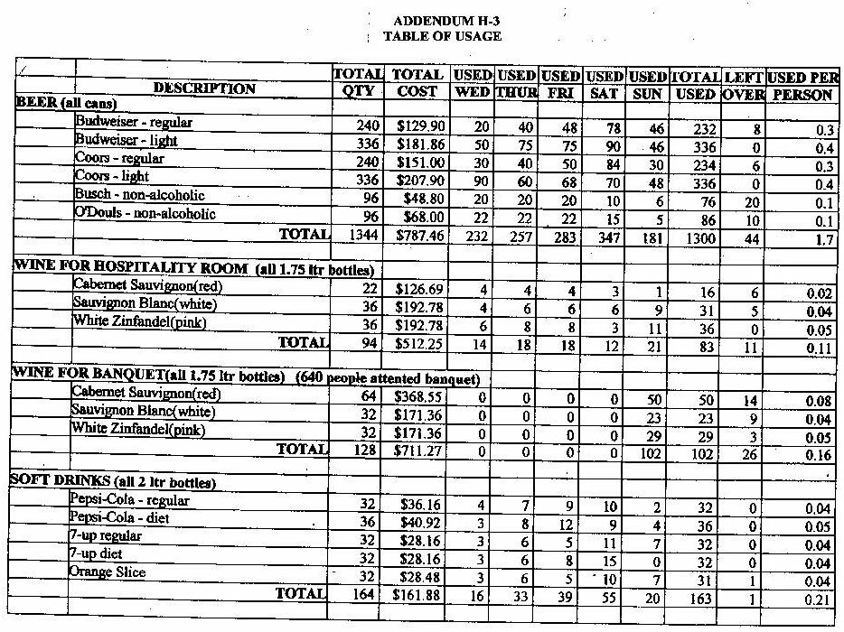

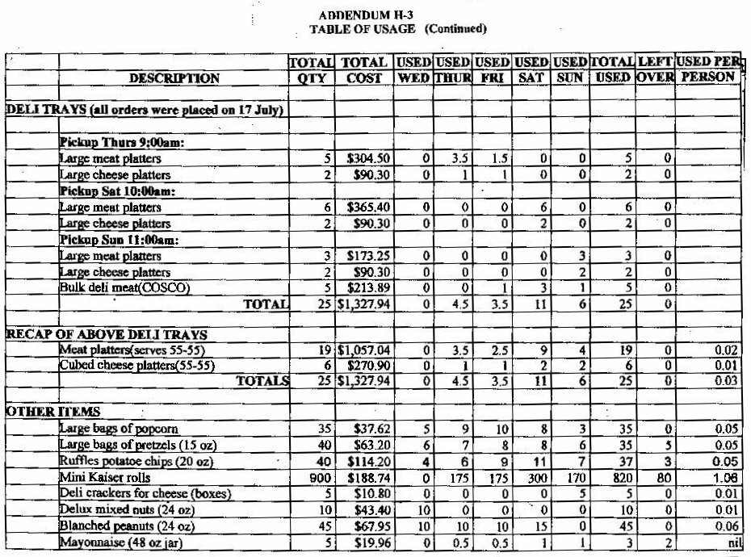
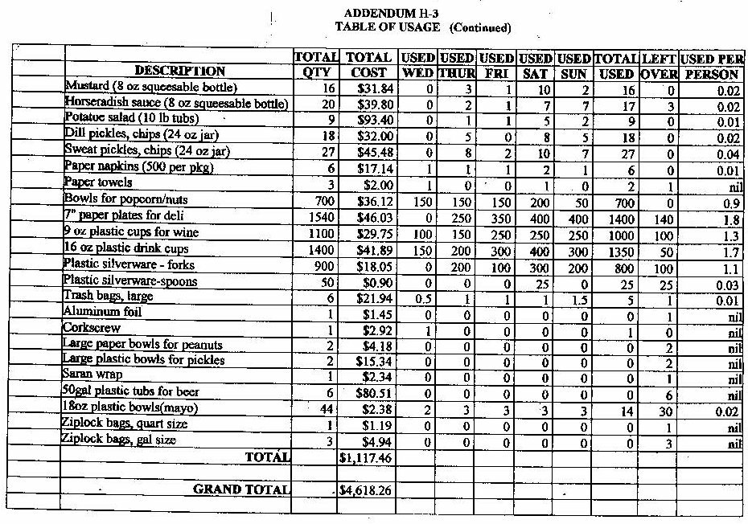

ADDENDUM M-1

Official Membership Application Form

The Korean War Veterans Association, Inc.

PO Box 22857, Alexandria, VA 22304-9285 (Telephone: 703-461-0061)
DO NOT WRITE IN THIS SPACE Assigned Membership Number: ____________________________

KWVA Regular Annual Dues - $25.00|Associate Membership - $12.00|Ex-POW, Gold Star Parent or Spouse & Honorary -$0.00
Regular Life Membership: (May be paid in lump sum or 6 equal payments by check over a 12 month period.)
Ages up to and through 35 years of age: $600 Ages 36 through 50 years of age: $450
Ages 51 through 65 years of age: $300 Ages 66 years of age and older: $150
Please Check One: |  New Member |  Renewal Member #___________

Please Check One: |  Ex-POW |  Regular Member |  Regular Life Member |  Associate Member
 |  Honorary |  Gold Star Spouse |  Gold Star Parent

(Please Print)
Last Name:____________________ First Name:_______________ Middle/Maiden Name ___________
Street______________________________ City__________________ State ____ Zip __________
Phone ____-____-________ Email ______________________________________________________
Name of Chapter (if applicable) _________________________________________________________
-All regular members please provide the following information-
Unit(s) to which Assigned |  | Branch of Service | Dates of service:  WithIN Korea were: (See criteria below)  From: ___________ To:___________  WithOUT Korea were: (See criteria below)  From: ___________ To:___________
Division __________________ |  |  Army
Regiment _________________ |  |  Air Force
Battalion _________________ |  |  Navy
Company _________________ |  |  Marines
Other ____________________ |  |  Coast Guard

“I certify, under penalty of law, that the above information provided by me for the purposes indicated is true and correct."
[If you are applying for membership in a category other than Section 1, par A.1., of the “Criteria for Membership” listed below, complete the “Certification of Eligibility for KWVA Membership” form.]
Signature: __________________________________ Date: ___________________
Make checks payable to: KWVA
Mail to: Korean War Veterans Association, Inc., PO Box 22857, Alexandria, VA 22304-9285 (Telephone: 703-461-0061)
[Credit card payment not acceptable for installment payment of life Membership dues]
Credit Card # ______________________________________  VISA  MASTER CARD
Expiration Date _____________________ Signature___________________________________

Adopted 10/10/2006 [KWVA Membership Application Form Page 1]
ADDENDUM M-2

CERTIFICATION OF ELIGIBILITY FOR KWVA MEMBERSHIP

In addition to completing the KWVA membership application form on page 1 above, persons who make application for membership and qualify under one of the categories listed below, are required to fill in the appropriate blanks, sign in the space provided below and attach this page to the completed membership application form on page 1.

Check
One

______ Medal of Honor: I am a recipient of the Medal of Honor for service during the Korean War and the date on which it was awarded was: Month _____ Day ____ Year_____.

______ Ex-POW: I was held as a Prisoner of War at some time during the period June 25, 1950 to the present,
From: Month ____ Day ____ Year ____ To: Month ____ Day ____ Year ____.

______ UN Command/Korean Armed Forces: I served honorably in the Armed Forces of the United Nations Command or in the Republic of Korea Armed Forces during the Korean War era (June 25, 1950 - January 31, 1955):
From: Month ____ Day ____ Year ____ To: Month ____ Day ____ Year ____.

______ Gold Star Parent: I am the parent of : Name [print]_______________________________, who was
( ) killed in action, ( ) missing in action or ( ) died as a Prisoner of War
on: Month _____ Day ____ Year _____.

______ Gold Star Spouse: I am the spouse of: Name [print] _________________________, who was
( ) killed in action, ( ) missing in action or ( ) died as a Prisoner of War
on: Month _____ Day ____ Year _____.

______ Associate: I have a legitimate interest in the affairs of the Korean War Veterans Association and agree to accept the terms and conditions set forth in its charter and bylaws.

______ Honorary: I was elected as an honorary member of KWVA by a vote of the Board of Directors
on: Month _____ Day ____ Year _____.

“I certify, under penalty of law, that the above information provided by me for the purposes indicated is true and correct."

Signature: _____________________________________________ Month _____ Day ____ Year _____

Adopted 10/10/2006 [KWVA Membership Application Form Page 2]

ADDENDUM M-3

CRITERIA FOR MEMBERSHIP IN THE KOREAN WAR VETERANS ASSOCIATION, INC.
Section 1. Qualifications of Members. Membership in this Association shall consist of Regular, Associate and Honorary Members. No person shall be excluded from membership because of race, color, creed, sex, national or ethnic origin, or physical or mental disability, as long as the individual meets the criteria of service requirements as stipulated below. Only Regular Members as defined in A. below have a vote in National or Department matters.

A. Regular Members.
- Service in the United States Armed Forces. Any person who has seen honorable service in any of the Armed Forces of the United States, defined as Army, Navy, Marines, Air Force and Coast Guard, said service being within Korea including territorial waters and airspace (September 3, 1945 – Present) or who served outside of Korea ( June 25, 1950 --January 31, 1955), is eligible for Membership.
- Medal of Honor. Any Medal of Honor recipient, so honored for service during the Korean War is eligible for life membership. A signed statement of their eligibility for membership [Application Form page 2] must be provided for approval.
- Prisoner of War. Any person held as a prisoner of war by the North Koreans, Chinese, or Russian forces during and after hostilities from June 25, 1950 forward is eligible for life membership. A signed statement of their eligibility for membership [Application Form page 2] must be provided for approval.
- United Nations Command and Korean Armed Forces. Any person who served honorably in the Armed Forces of the United Nations Command or in the Republic of Korea Armed Forces during the Korean War era (June 25, 1950-January 31, 1955) is eligible for membership. However, UN/Korean membership of the Association may not exceed 10% of the total membership. A signed statement of their eligibility for membership [Application Form page 2] must be provided for approval.
- Gold Star Parents. Any person whose son/daughter was killed in action, or was missing in action, or died as a prisoner of war during the Korean War is eligible for life membership. A signed statement of their eligibility for membership [Application Form page 2] must be provided for approval.
- Gold Star Spouses. Any person whose spouse was killed in action, missing in action, or died as a prisoner of war during the Korean War is eligible for life membership. A signed statement of their eligibility for membership [Application Form page 2] must be provided for approval.

B. Associate Members. Any person with a legitimate interest in the affairs of this Association and who wishes to support its aims, and not being eligible for Regular membership and who agrees to accept the terms and conditions set forth in the charter and bylaws shall be eligible for associate membership in the Association. A signed statement of their eligibility for membership [Application Form page 2] must be provided for approval.

C. Honorary Members. Any person of good character may be elected as Honorary Member by vote by the Board of Directors. A signed statement of their eligibility for membership [Application Form page 2] must be provided for approval.

D. Ineligible. Any person who has been separated from the service of the Armed Forces of the United States, or the United Nations Command, or the Republic of Korea under conditions other than honorable shall be ineligible for membership in this Association.
WEB SITE: www.kwva.org
Adopted 10/10/2006

ADDENDUM N-1

CHAPTER/DEPARTMENT FORMATION PROCEDURE

The following items are an example of a procedure to follow to help a Membership Recruiter to form a Chapter/Department in the Korean War Veterans Association.

1. Send a Form Letter to known KWVA members in a city or area asking if there are any members interested in forming a Chapter in their area. If so are they willing to serve as a Formation Officer until election can be established with Chapter Bylaws used.

2. If a Department is available in the State contact the Department President and inform him/her that the possibility of forming a new Chapter exists. Coordinate obtaining a recruiter with the Department and send the items for Chapter formation listed below for use.

3. If the Department requests a Chapter be formed in their State coordinate with the President and in the case a member requests that a Chapter be formed in his/her area again coordinate with the Department President if a Department exists in the State the Chapter wishes to form in. If no Department exists continue to assist the individual in trying to form the requested Chapter or give the individual information on who to contact, for help in the State the Chapter is trying to form in, for guidance.

4. In the case of a Department, select a Chapter within the State to help form the Department.

5. Once a contact is made send the following items listed:

a. Copy of the National Petition for obtaining the necessary information to begin the charter process.

b. Copy of the current National Bylaws. In the case of a Department, skip to Item f.

c. At least twelve (12) copies of the National Application for membership to a chapter.

d. A copy of a press release for Newspapers and local Radio Stations in the area to help locate new members as the Chapter begins its formation.

e. Stamps and a list of National Member addresses in the formation Chapter’s area.

f. Copy of Oath of Office.

g. Following the Charter of the Chapter/Department, send a sample copy of the Incorporation paperwork used to obtain Incorporation in the State. It is available on the State Attorney Generals Office of Incorporation Web Site.

h. Send Internal Revenue Service Forms SS-4, & Instructions for Form SS-4 used to obtain an Employer Identification Number (EIN), to open a bank account, and Publication 557 and Form 1024 to obtain a Tax Exemption status as a 501(c)19 Veterans Organization. All of these items are available on the Internal Revenue Website at www.irs.gov .

ADDENDUM N-2

CHAPTER PETITION FORM - PAGE 1
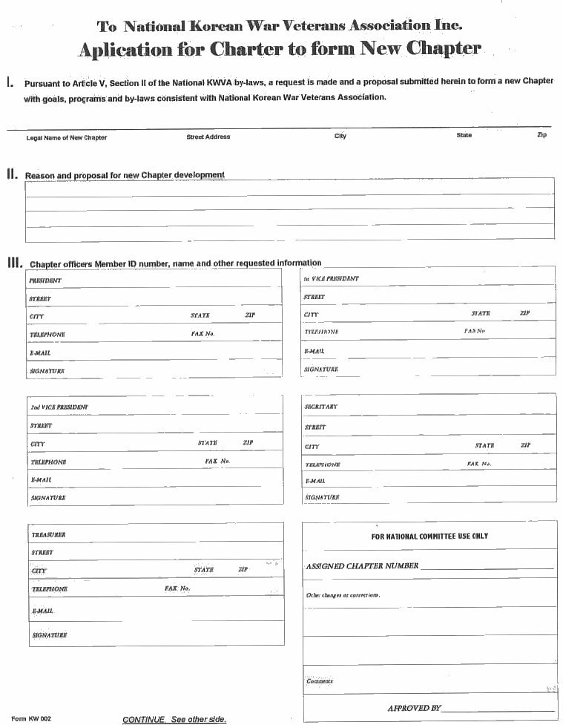
ADDENDUM N-2

CHAPTER PETITION FORM - PAGE 2
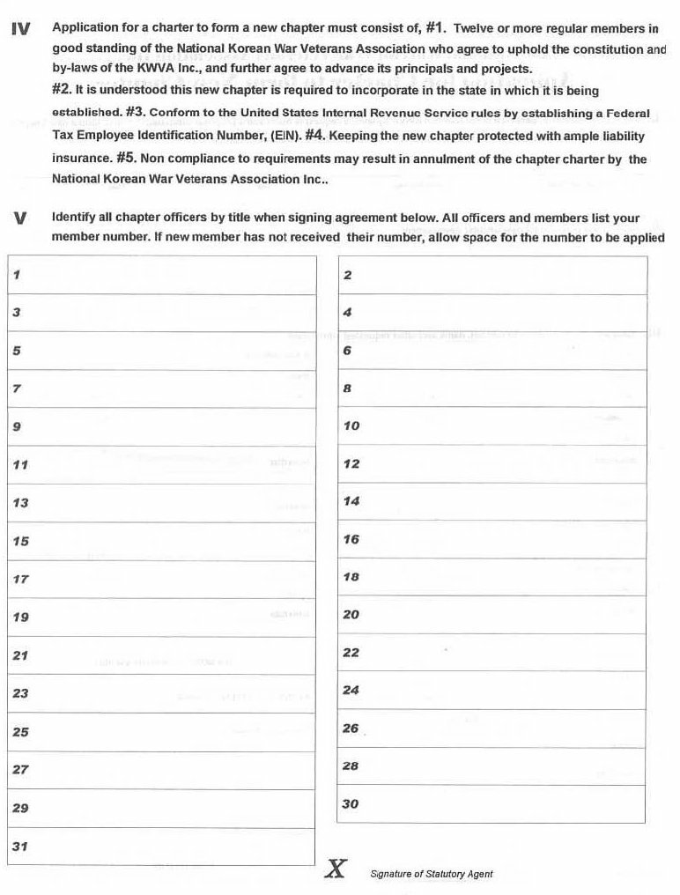
ADDENDUM N-3

DEPARTMENT PETITION FORM
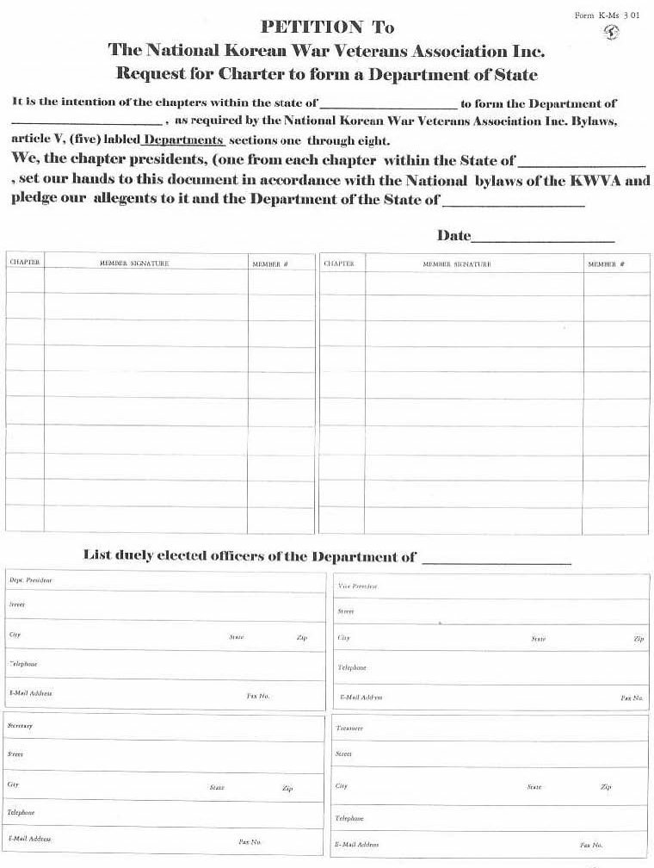
ADDENDUM N-4

CHAPTER/DEPARTMENT CHARTER PROCEDURE

Chapter and Department organizing activities take place by various means: Membership Committee Representative, write-ins from at-large-members and from established Chapters and Departments. Chapter and Departments require a Charter to be accepted into the Korean War Veterans Association.

To obtain a Charter the following procedure is required:

1. An Approved Petition Form must be presented to those wanting to form a Chapter by the Department by the state where the Chapter will be formed. In the case where there is no Department the Membership Committee Chairman will act as the conveyor of the Petition. The Membership Chairman will arrange to supply the Petition Form.

2. If there is a Chapter in the area, the Membership Chairman may designate an individual from that Chapter or a Membership Committee Member to act as a focal point to help in the new Chapter/Department formation.

3. If a Department exists, the petition when completed is sent to the Department which will relay the petition to the Membership Administrative Assistant, along with any funds for new memberships required. If no Department exists the Membership Chairman will arrange to send the Petition to the Membership Administrative Assistant.

4. The Membership Administrative Assistant will verify that the Petition contains the required charter information, at least twelve (12) members in the case of a Chapter or at least four Chapters in the case of a Department. A check is made to assure that all members are current in their membership in the KWVA. The members will be entered into the membership records and assigned the CID# of the Chapter being formed. The Petition is then forwarded to the National Secretary.

5. The Secretary will prepare the Charter and forward it to the National President for the final approval signature.

6. The National President will forward a ‘Chapter Charter to the Department President for presentation to the Chapter. If there is no Department, the National President will arrange for suitable presentation to the Chapter.

7. The National President will arrange for suitable presentation of a Department Charter.

8. When the new Chapter/Department develops its Bylaws and/or prepares its Incorporation Application, according to the State Incorporation laws, it will forward them to the Judge Advocate for review and approval.

9. The Judge Advocate will return the approved documents to the Chapter/Department and send a copy of both to the National Secretary.

Note: If any questions arise in this organizational process relating to Bylaws, the Judge Advocate should be consulted.

ADDENDUM N-5

MEMBERSHIP COMMITTEE FUNCTIONS AND ACTIVITIES

1. Conduct Recruiting Training as requested by the Board or President.

2. Recruit members who served in Korea from September 3, 1945 to present or served during the Korean War Era from June 25, 1950 - January 31, 1955. Associate members are welcome into the KWVA. All Departments, Chapters and at-large-members geographically spread throughout the United States and territories.

3. Committee is made up of:
a) Chairman
b) Deputy Chairman
c) Secretary
d) All Departments, Chapters and at-large-members geographically spread throughout the United States and territories.

4. Membership Chairman will make final decisions on the publicity and any training after input by these committee members.

5. Increase membership rolls of KWVA by means of:
a) posters
b) decals
c) flyers
d) newspaper articles
e) radio
f) TV
g) Tell America Program
h) scanning organization websites and newsletters

6. Work closely with KWVA Secretary and monitor the progress of the Recruiting Program in obtaining new members and retaining current members.

7. Saturate the country with KWVA name, logo, and products.

8. No budget is specifically allocated to recruiting. The main source of revenue will come from its decal program which has ads in both The Graybeards Magazine and on the KWVA National Website.

9. Send recruiting members or teams of recruiting members to various chapters to inform them how to recruit members and educate them on the new Korea Defense Service Medal that was issued to four million postwar Korea veterans and counting. These veterans are the future and lifeline of the KWVA.

10. Travel will only be conducted when financially possible.

11. Always look for opportunities to recruit members.

ADDENDUM R-1

RESOLUTIONS/BYLAWS CHANGES

Resolutions are a formal means of presenting ideas for consideration (a motion) to the Board of Directors. Thus a Resolution is a motion in a form to help organize points in clear writing, along with the clear action plan to be followed. Resolutions written in the same style and form will help expedite the Board of Directors meetings. A Resolution is presented to the KWVA Resolutions Committee Chairman for the Resolutions Committee to determine and recommend to the Board of Directors, a course of action and why the course has been selected, to either approve, disapprove or to postpone or pass on to another committee for further consideration. The Resolution must be submitted at least forty-five (45) days prior to a called Board of Directors meeting where it will be brought before the Board of Directors. A Resolution to change the Bylaws must be sent to the Bylaws Committee Chairman, not the Resolutions Committee Chairman, at least forty-five (45) days prior to a called Board of Directors meeting, to insure it reaches the Bylaws Committee in time for the Bylaws Committee to form its recommendation to the Board of Directors.

Each Resolution must be signed, and National Member Number included, by at least two Regular Members of the Korean War Veterans Association, Inc. In the case of a Department or Chapter, a letter of endorsement must accompany such Resolution with the signature and/or signatures of the President or Chapter Representatives including their National Member Number and stating their authority to do so.

Each Resolution received by either the Resolutions Committee or Bylaws Committee Chairman shall be given a number beginning with year received, date received and number: Example 2000-6/12-01.

A letter will be sent by the Committee Chairman for each Resolution submitted, stating its arrival and acceptance or rejection and expected presentation to the Board of Directors. Once the Resolution has been accepted or rejected by the Board of Directors the Committee Chairman will so notify those who submitted the Resolution of the results. See SAMPLE Letter, Addendum R-3. The Resolution results shall be included in the next published minutes of the Board of Directors and the Secretary shall place the Resolution and results with the minutes file.

Preparation Process:

1. Some of the many purposes which a resolution to the Board of Directors might address are as follows. Establishment of a specific policy, to demand the enforcement of an existing policy; to acknowledge or reward activities of members or to promote the change of bylaws and operational procedures of the Association.

2. Cover just one subject.

3. Research the purpose by gathering documentation to support the proposed Resolution.

4. Draft the Resolution with a Preamble, so called because it precedes the Resolving Clause(s). Each preamble paragraph, will state a separate reason and will be preceded by the word “WHEREAS”.

5. The Resolving Clause, so called because it begins with the words “RESOLVED THAT”; states who will do what.

6. The number of “WHEREAS” and “RESOLVED THAT” do not determine how good a Resolution is. The perceived purpose and action to be taken are what is important. Too much information or hearsay will clutter a well-meaning Resolution presentation.

ADDENDUM R-2

SAMPLE RESOLUTIONS/BYLAWS CHANGE REQUEST

Note: Use Bold and Capital Letters for Title, WHEREAS: and BE IT RESOLVED:

KOREAN WAR VETERANS ASSOCIATION, INC.
UNAUTHORIZED USE OF MEMBERSHIP ROSTERS

WHEREAS: Unauthorized use of the membership lists of the Korean War Veterans Association, Inc. (KWVA) has occurred on many occasions; and

WHEREAS: This unauthorized use is a breach of ethics by members, as well as officers and of the privacy of KWVA members; and

WHEREAS: There is no written guidance for the Membership Committee who is responsible for maintaining the membership list; therefore

BE IT RESOLVED: That the National Board of Directors require that all inquiries for a membership list be in writing with a statement stating who, what and why the list is required. A statement is included that the list is for use only for State Department or Chapter use to solicit members in their areas. This procedure is to be placed in effect with the approval of this Resolution.
===============================================================
KOREAN WAR VETERANS ASSOCIATION
BYLAWS RESOLUTION

WHEREAS: In its rejection of Resolution R7/27/04-01 to change the Korean War Veterans Association, Inc. (KWVA) Bylaws, ARTICLE X, ELECTIONS, Section 2, Board of Directors, the Board of Directors expressed the feeling that they had the right to replace any elected Board Member; and

WHEREAS: Members of the Board are elected by the Board of Directors, but a vacancy on the Board for other than recall is currently filled by the Board itself; therefore

BE IT RESOLVED: That the KWVA Bylaws, ARTICLE X, ELECTIONS, Section 2 Board of Directors, paragraph 3, second sentence be amended to read: “Vacancies on the Board of Directors other than those by a recall removal shall be filled nominated and approved, by a majority vote of the Board of Directors remaining members of the Board of Directors for the election unexpired term at the next Board of Directors meeting.”

ADDENDUM R-3

SAMPLE LETTERS RE: RESOLUTIONS/BYLAW CHANGES

KOREAN WAR VETERANS ASSOCIATION, INC
[RESOLUTIONS/BYLAWS] COMMITTEE CHAIRMAN
JOHN WRITER
123 NORTH POPULAR ST
JESSIEVILLE, AL 72243-6704

16 March 2004

[Leonard Jobe,
[Member or Officer Position]
[Chapter or Department]
[Address]
[Anywhere, US 77777

[Paul or President Name]

*This letter has been sent to tell you that your [Resolution/Bylaw Change] request has been received.

“Thank You” for your submittal and interest in the Korean War Veterans Association, Inc. The [Resolution/Bylaw Change] number for your submittal is Z6/12/04-00 [Z = R for Resolution /B for Bylaw Change, Date & Number]. The [Resolutions/Bylaws] Committee has your [resolution/bylaw change] under study and will present it to the Board of Directors with our recommendation, to either approve or disapprove and the reason. The Board of Directors has final approval on all changes presented no matter what the [Resolutions/Bylaws] Committee recommends. You will be notified of the approval or rejection, and in the case of rejection, the reason for the Committee or Board of Directors rejection.

Again, thank you for your interest in the Association!

Jeff Moore,
[Resolutions/Bylaws] Committee Chairman

*INSERT IN PLACE OF THE ABOVE TWO PARAGRAPHS FOR FOLLOW UP LETTER.

This letter has been sent to tell you the Board of Directors has [approved/rejected] your [Resolution/Bylaw Change].

The [Resolutions/Bylaws] Committee recommended that the Board of Directors [approve/reject] your [Resolution/Bylaw Change]. (In the case of the Board of Directors approving the requested change there is no need of an explanation of why, but a ‘THANKS’ for their request is given again. If the [Resolution/Bylaw Change] is rejected and the Committee recommended rejection, the reason should be given as to why it recommended rejection or why the Board of Directors rejected the requested change over the recommendation to approve by the Committee.

